FLORIDA VIRTUAL ENTREPRENEUR CENTER
Major funding provided by the Florido High Tech Corridor Council

WWW. FLVEC. COM

Whether starting a new business, looking to expand an existing business or considering relocating a business, entrepreneurs searching for information that will support their business needs can visit the Florida High Tech Corridor Council's (FHTCC) Florida Virtual Entrepreneur
Center (www.flvec.com). Created as a robust and easy-to­ use one-stop online resource, this Web portal is maintained by FHTCC in partnership with local economic development organizations. Updated regularly with new information, the Florida Virtual Entrepreneur Center (FLVEC) catalogs local, regional, state and global resources for starting and growing a business.

Find a resource. List your resource.

WWW. FLVEC, COM

Today, through partnerships with Entrepreneur Support Organizations (ESOs), FHTCC's FLVEC promotes statewide and national services for Florida's 67 counties. A leading online source for entrepreneurial services, the website has continually garnered a 10 percent monthly increase in
visitors that generate more than 10,000 monthly page views. FHTCC's initiative has brought together chambers of commerce, economic development organizations, workforce boards, county and municipal governments, private and public companies and entrepreneurial programs, building a statewide community in support of
entrepreneurial endeavors.
FLVEC is designed to be a free, up-to-date library for entrepreneurs looking for business resources. The website provides links within each county to all the latest business resources- such as local permitting codes and forms, statewide corporate registration information and federal trademark law. FLVEC services are available throughout all of Florida's 67 counties, and each portal is constantly growing with the addition of new entrepreneurial
resources.

Uses of flvec.com

Established business owners that offer services catering to entrepreneurs have the opportunity to utilize FLVEC as a company directory. Whether specializing in law, accounting, IT, communications or other products and services, businesses around the state can list their information on FLVEC at no charge to help entrepreneurs find the best products and services for starting or growing a business. Because FLVEC is continually updated and maintained, entrepreneurs are encouraged to log on regularly to find the latest information about new products and services.

About FHTCC

The Florida High Tech Corridor Council is a regional economic development initiative of the University of Central Florida (UCF), the University of South Florida (USF) and the University of Florida (UF) whose mission is to grow high
tech industry and innovation through research, workforce
and marketing partnerships in the 23-<:ounty Corridor.

A partnership involving more than 25 local and regional economic development organizations (EDOs), 14 state and community colleges, and 12 regional workforce boards,
the Council is co-chaired by the presidents of UCF, USF
and UF. The unique partnership has resulted in a strategic approach to high tech economic development that involves matching funds research, workforce development and a marketing program leveraging governmental, EDO and corporate budgets on a regional rather than local basis.

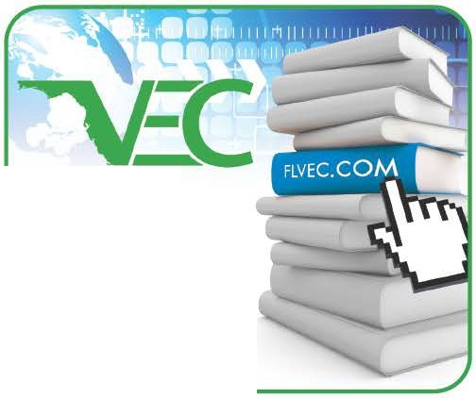

Florida High Tech Corridor Council
1055 AAA Drive, Suite 140, Heathrow, FL 32746 • (407) 708·4630 • www.FioridaHighTech. com

